# User Notification Portlet in Liferay DXP

Many new features have been added in Liferay 7 and many user-friendly notifications omitted. Take for example, the feature that notified users and developers when there was a change with their project or system they were working on.

It was User Notification Portlet that was very much visible on the right hand side corner in Liferay 6.2 assigned a bell icon with numbers shown in red colors indicating the changes or updates that are still to be viewed by the user. With the introduction of Liferay DXP that features has been disabled.

## **Problem**

Liferay 6.2 showed notifications to user in its top dock bar (Bell icon that showed numbers in red circle) to access notifications for latest updates. But, with Liferay DXP we can only access then via the Control Panel section which is inconvenient due to navigational issues.

## **Solution**

KNOWARTH’s User notification Portlet is the solution to circumvent this annoying issue. We have developed a unique component in Liferay 7 using which developers can allow access to users to view notifications in real-time. It also allows a user to redirect notifications to Liferay User Notification Page for convenience.

**How to configure Notification Portlet in Liferay DXP?**Please follow below given steps to configure Notification Portlet:

**Step 1**: Paste the .war file in deploy folder on Tomcat Server

**Step 2**: Login as Super Admin in your Liferay account

**Step 3:** Create public page in any site and add Portlet (User notifications) in that same page.

**Step 4**: set Portlet URL (notification page URL) to get redirected to the Notification Page on your Liferay account

Now, click on configuration option on top Right menu of User Notification Portlet as shown in the image below.

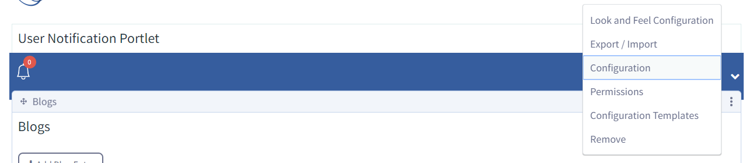

Above steps will Pop open a new window which will prompt a user to add the redirection URL. Click the Save button to save you redirection rule.

**For example:** /group/control_panel/manage?p_p_id=com_liferay_notifications_web_portlet_NotificationsPortlet&p_p_lifecycle=0&p_p_state=maximized&p_p_auth=8U5tPQxH

**Please refer to the Liferay Portal image shown below for reference.

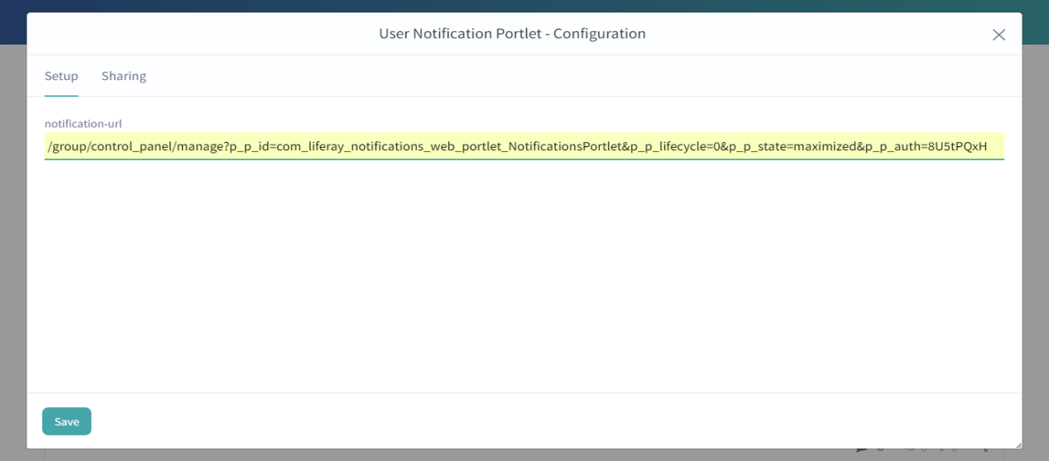

**Step 5**: Generate user notifications.

For example: create a blog. Login with any other user and subscribe that user to the blog you just created.

And, that subscriber will get all notification for any updates, comments or changes within the blog.

**Step 6:** After generating notification, go to site page where User notification Portlet is available.

We can see notifications for the new user in the Portlet by clicking on Bell icon. 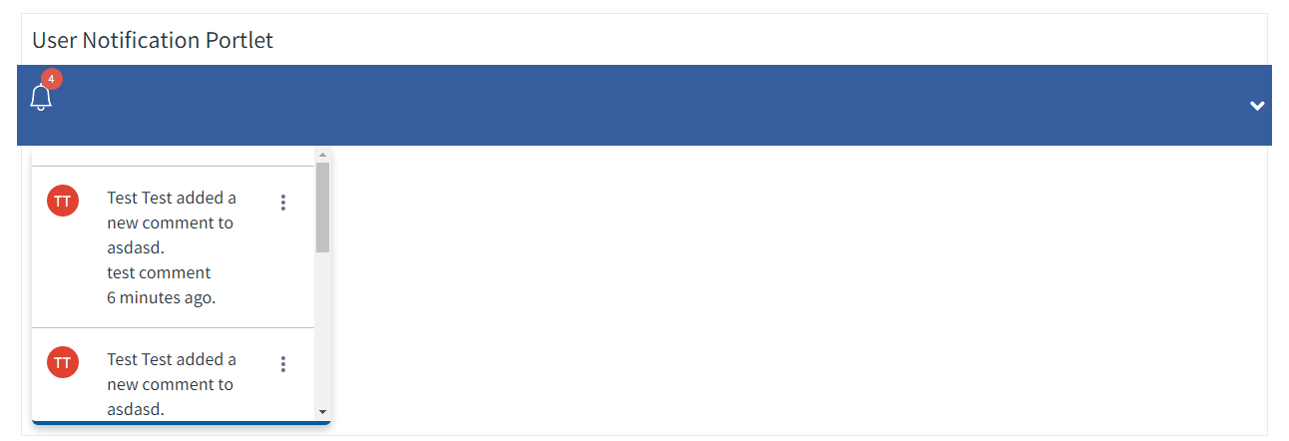

**Step 7**: User can mark it Read to hide that update.

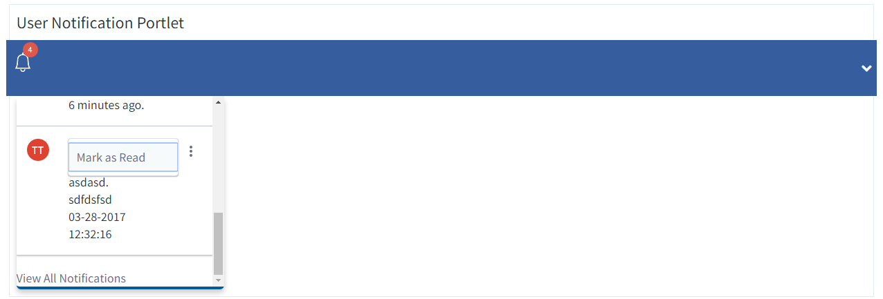

**Step 8:** By clicking on View all notifications, user will get redirected to notifications page available in Liferay’s Control Panel section.

As shown below.

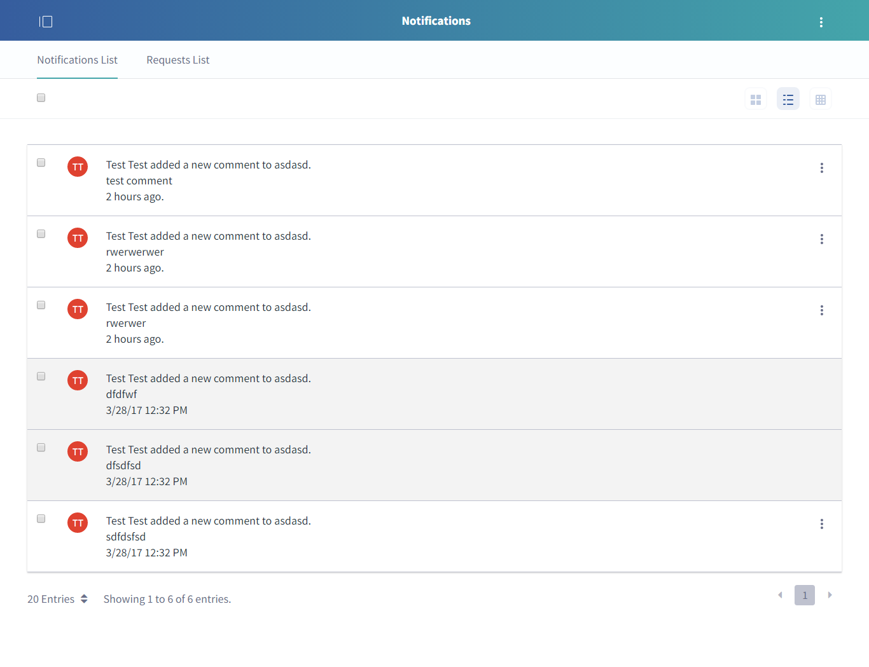

User notifications are very important to most users as it draws their attention to the latest updates within their projects.